**6) Test the usability of a website or application. This might involve testing how easy it is for users to navigate the website or application, find information, and complete tasks.**

Here the validation of navigating one page to another page functionality and able to find the information and add the product into the cart without any loading or delaying issue.

**Adding items to cart.**

Adding the products into cart by selecting and click on add to cart.

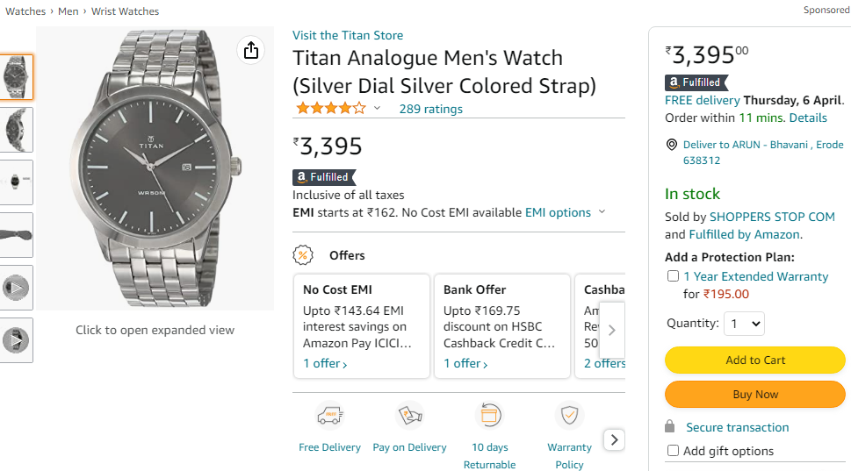

**Adding/Selecting shipping address.**

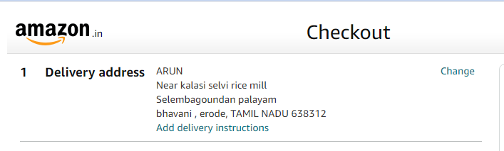

Selecting the product shipping address regarding needs.

**Entering payment details.**

Selecting and entering payment details of the order**.**

